Hello, I am Darshan. I attend the Go language two workshop and I really learn lot of here. Even before attending this workshop I don’t know about this language. But after attending this workshop I learn this language and my confidence is also build about this language. Thank a lot sir. Here I show some little things That I learnt during the workshop.

My learning start here:-

1. package main

import (

"fmt"

)

func main() {

fmt.Println("Hello World")

}

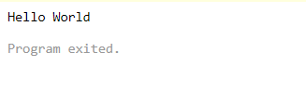

2. package main

import "fmt"

var a int

func main () {

fmt.Println(a)

}

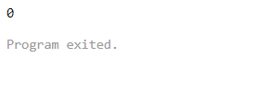

3. package main

import "fmt"

func main() {

var i int = 1

var w float64 = 12.5

fmt.Println(i, w)

}

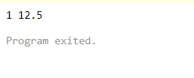

4. // of := (short declaration

// operator)

package main

import "fmt"

func main() {

// declaring and initializing the variable

a := 30

// taking a string variable

Language := "Go Programming"

fmt.Println("The Value of a is: ", a)

fmt.Println("The Value of Language is: ", Language)

}

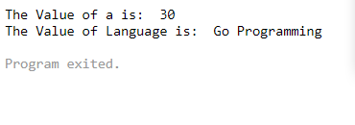

5. package main

import (

"fmt"

)

func main() {

var i, j, k = 1, 2, 3

var (

name = "Sangam Biradar"

occupation = "Developer Advocate"

)

fmt.Println(i, j, k)

fmt.Printf("%s is a %s\n", name, occupation)

}

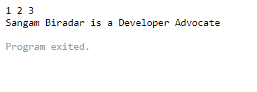

6. package main

import (

"fmt"

"reflect"

)

func main() {

var name = "Sangam"

var age = 25

fmt.Println(reflect.TypeOf(name))

fmt.Println(reflect.TypeOf(age))

fmt.Printf("%s is %d years old\n", name, age)

}

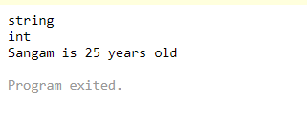

7. package main

import "fmt"

var word string = "Learning"

func main() {

i := 12

fmt.Println(word)

fmt.Println(i)

test()

}

func test() {

fmt.Println(word)

}

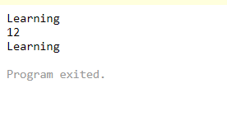

8. package main

import (

"fmt"

"path"

)

func main() {

var file string

_, file = path.Split("css/main.css")

fmt.Println("file",file)

}

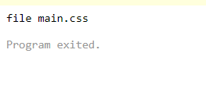

9. This the link for q no 9 this is not working in online complier you can use GO Land software

<https://play.golang.org/p/OfsK2gDYOhF>

10. package main

import (

"fmt"

"os"

)

func main() {

fmt.Printf("%#v\n", os.Args)

}

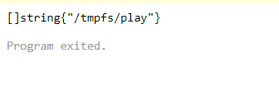

11. package main

import "fmt"

func main() {

var s string

s = "how are you?"

s = `how are you?`

fmt.Println(s)

s = "<html> \n\t <body> \"hello\"</html>"

s = `

<html>

<body> "hello" </body>

</html> `

fmt.Println(s)

fmt.Println("c:\\my\\dir\\file")

fmt.Println(`c:\my\dir\file`)

}

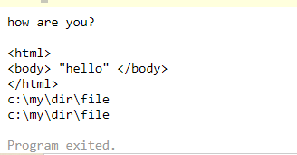

12. package main

import "fmt"

func main() {

name := "sangam"

fmt.Println(len(name))

}

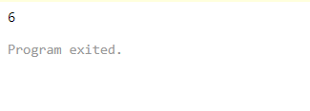

13. package main

import "fmt"

func main(){

const (

monday = 0

tuesday = 1

wednesday = 2

thursday = 3

friday = 4

saturday = 5

sunday = 6

)

fmt.Println(monday,tuesday,wednesday,thursday,friday,saturday,saturday,sunday)

}

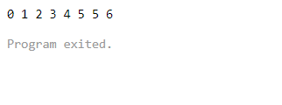

14. package main

import "fmt"

func main(){

const (

monday = iota

tuesday

wednesday

thursday

friday

saturday

sunday

)

fmt.Println(monday,tuesday,wednesday,thursday,friday,saturday,saturday,sunday)

}

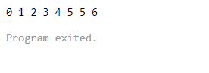

15. package main

import "fmt"

func main(){

const (

monday = iota + 1

tuesday

wednesday

thursday

friday

saturday

sunday

)

fmt.Println(monday,tuesday,wednesday,thursday,friday,saturday,sunday)

}

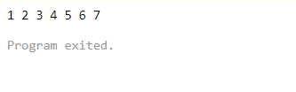

16. package main

import "fmt"

func main(){

const (

EST = -(5 + iota)

_

MST

PST

)

fmt.Println(EST,MST,PST)

fmt.Println()

}

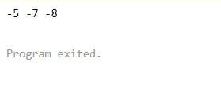

17. package main

import (

"fmt"

"strconv"

)

func main() {

s := strconv.Itoa(42)

fmt.Println(s)

}

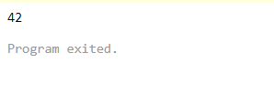

18. package main

import (

"fmt"

"strconv"

)

func main() {

n, err := strconv.Atoi("42")

if err == nil {

fmt.Println("there was no error , n is ", n)

}

}

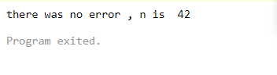

19. package main

import (

"fmt"

"strconv"

)

func main() {

if n, err := strconv.Atoi("42"); err == nil {

fmt.Println("there was no error , n is ", n)

}

}

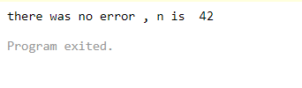

https://play.golang.org/p/S5or0bckhoW

20. package main

import "fmt"

func main() {

city := "Chandigarh "

switch city {

case "Chandigarh ":

fmt.Println("india")

}

}

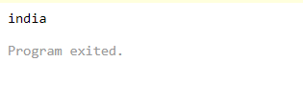

21. These are the links for more and different type of code:-

<https://play.golang.org/p/R4dJ8eWGr2Z>

<https://play.golang.org/p/uZNvA67svHV>

<https://play.golang.org/p/XNstN9cpu7Y>

<https://play.golang.org/p/YCqwRIcQGuE>

<https://play.golang.org/p/9KPRRBQpzTN>

<https://play.golang.org/p/RCSlcLEMJKN>

<https://play.golang.org/p/8y_2hn7qHZo>

<https://play.golang.org/p/wEgzCAaFwLa>

<https://play.golang.org/p/tjxInWUXQNr>

<https://play.golang.org/p/JNlkkelUyjF>

<https://play.golang.org/p/6GTdDy_HOS->

<https://play.golang.org/p/Z8DBWThnoL5>

<https://play.golang.org/p/2KQ0wAlNR4r>

<https://play.golang.org/p/a4txb1c_YqA>

<https://play.golang.org/p/vKl4D50Xehn>

<https://play.golang.org/p/BKmohQ_XaZy>

<https://play.golang.org/p/sfXTQqODzsA>

<https://play.golang.org/p/sfXTQqODzsA>

<https://play.golang.org/p/9rosHZU_en5>

<https://play.golang.org/p/OAOT3FnPOh9>

<https://play.golang.org/p/GoXkiKDMU69>

<https://play.golang.org/p/3VhUdkZ-ebg>

<https://play.golang.org/p/4PBtnw1yRNp>

<https://play.golang.org/p/MZHyt-yMAkt>

<https://play.golang.org/p/1qGStp971Rs>